- Names: Van Dyke, J., Parker-Davis, P.
- Kit: SEPUP Issue Oriented Science / Evolution

- Unit: #91

- Grade Level: 8
- Hook: How can fossils be used to study the behavior of organisms that were alive millions of years ago?

- Hypothesis / Hypotheses: Using research and progressively changing evidence of trace footprint fossils, students formulate a hypothesis as to what might have occurred in a prehistoric encounter.

- Necessary prior knowledge / experience:

- Unit #89 & #90

- Adaptations to the procedures: The students should draw, measure & record their data in their notebooks, not the handouts.

- The white boards are perfect to “stand and defend” your position on the fossils.

- Lesson extension / addendum:
- Attached explanation of Darwin’s changing ideas about the geologic time scale.
- Actual trace fossils pictured below.

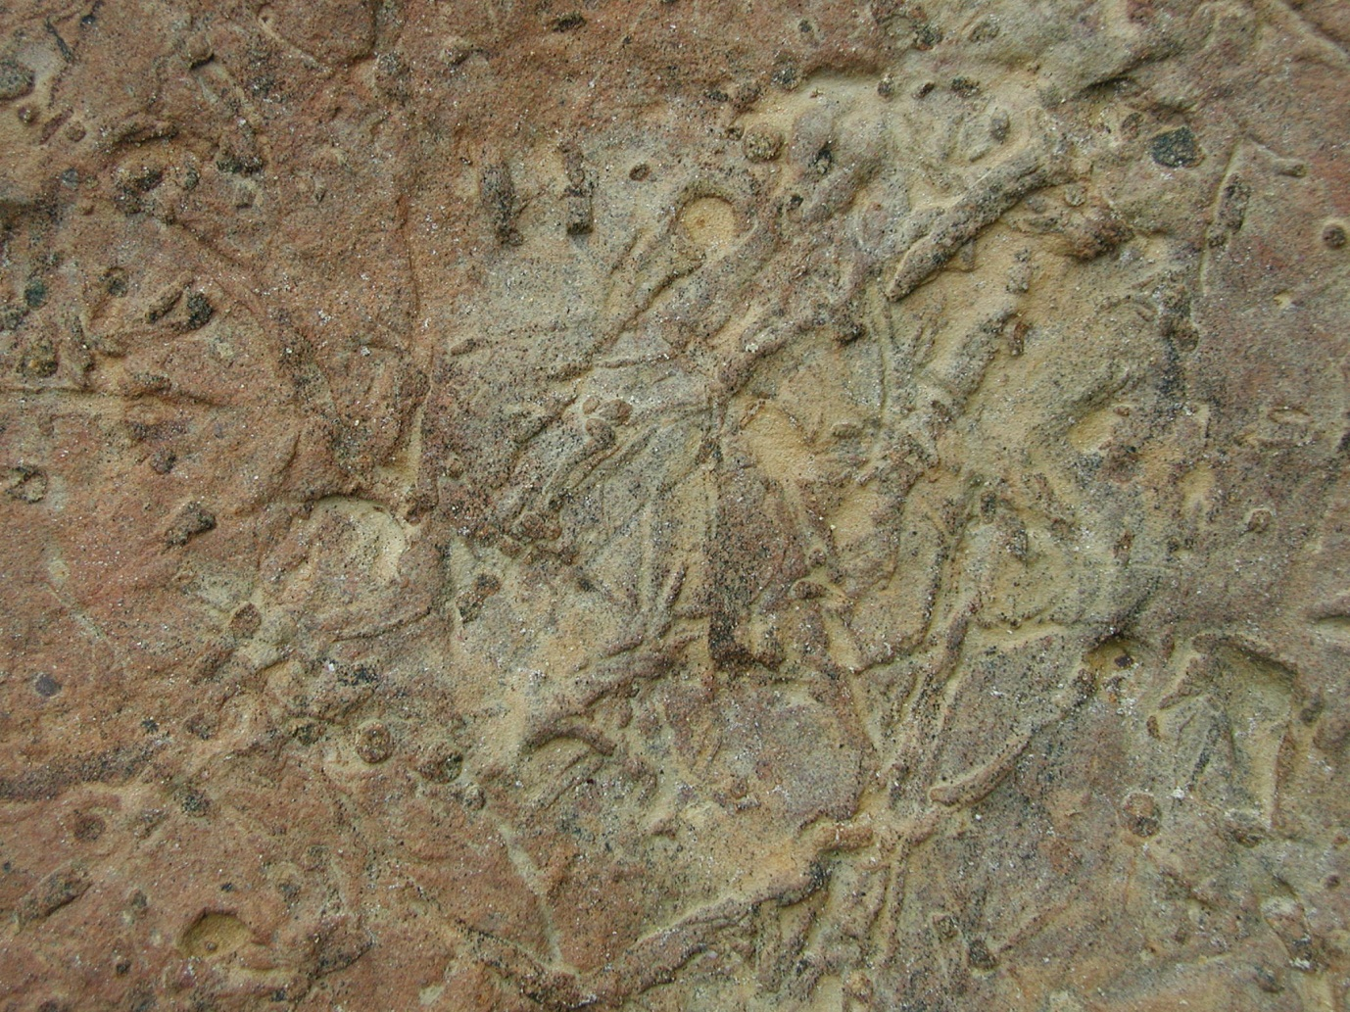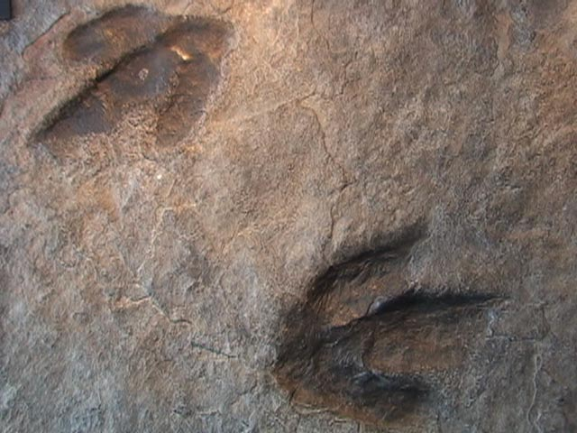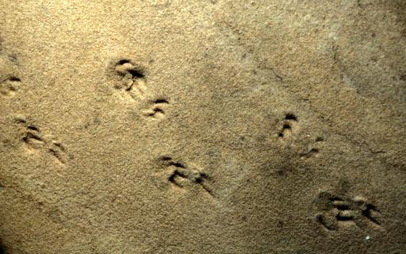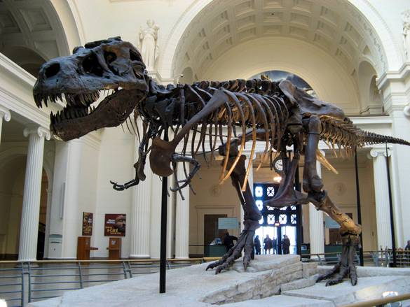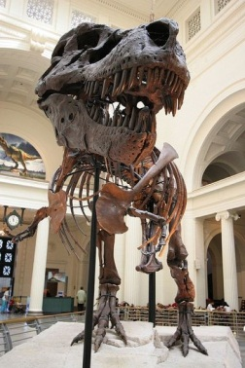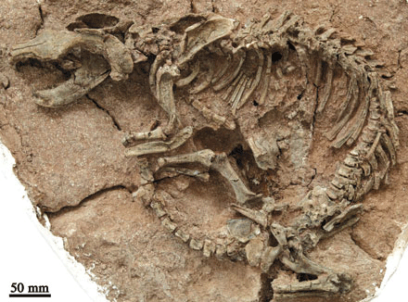RReflections: This was our favorite, most engaging of the lessons. The cards used could be larger or reproduced on white boards.

- `

