Modeling module for Biology Standard 3.1 Modeling Rate of Photosynthesis
Authors: Marian Biology Teacher group
Indiana standards
B.3.1 Describe how some organisms capture the sun’s energy through the process of photosynthesis by converting carbon dioxide and water into high-energy compounds and releasing oxygen.

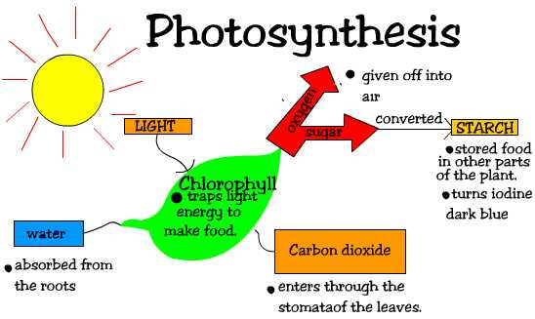
Demo/Discussion
Show the students a piece of elodea in a large sealed test tube.

What’s happening in this plant?
What does the plant need to survive?
How does this plant affect you?
What variables would affect the rate of photosynthesis?
How could you change the amount of CO₂ or light the plant receives?
Show them the photosynthesis elodea setup.
Whiteboard questions-
What would you expect to happen in this setup?
What variables could you change that might change the rate of photosynthesis?
How could you measure this change?
Show your results
Basic information
Have each whiteboard group write out the formula for photosynthesis so they can reflect on the potential inputs and outputs in photosynthesis.
Online simulations for exploration
In this simulation, you will be looking at the production of oxygen as a plant (the waterweed) photosynthesizes. Oxygen is measured in the number of bubbles produced by the plant. Three factors (light intensity, CO₂ concentration, wavelength of light) that influence the rate of photosynthesis can be adjusted in the simulator to determine how each of the factors affects the rate of photosynthesis.
http://www.saddleworth.oldham.sch.uk/science/simulations/waterweed.htm
Example photosynthesis setup
The volumeter is used to detect small changes in volume resulting from exchange of gases in photosynthesis or respiration. The volumeter is a closed system with the capability to measure the volume changes represented by the movement of a drop of liquid or an entrapped air bubble in a capillary tube.

The volume of oxygen given off during photosynthesis and carbon dioxide during respiration can be determined using elodea and pea seeds. Conditions must be carefully controlled to determine the amount of volume change. Temperature and barometric pressure must be kept constant during the experiment. This can be done by using the volumeter jar as a water bath.

1. Use a syringe or pipet to inject a small drop of colored water or soap bubbles into the capillary tubes.
2. Select a healthy, 4-6" twig of Elodea and place it in one of the tubes. Put room temperature distilled water in the tubes.
3. Place the rubber stopper containing the glass tubing in the opening of the test tube. Make sure the clamp is off the piece of tubing which serves as a pressure release valve.
4. Fill a glass water bath (glass jar, large beaker, small tank) to the halfway mark with room temperature water.
5. Insert the test tubes into the water bath. The water bath is only intended to keep temperature constant in the experimental and control tubes.
6. Insert the capillary tubes into the longer pieces of tubing from the two-hole rubber stopper assembly: keep the capillary tubes level.
7. Insert stoppers into the three test tubes. Leave the pinch clamps off the other piece of rubber tubing until the fluid levels in the tubes reach equilibrium.
8. Place the volumeter about 15 centimeters from a well lit window or growth lamps and
adjust the light so that it is shining on the test tubes.
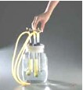
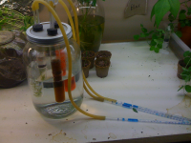
Teacher Notes
Potential variables that students might select: amount of light or no light, CO₂ concentration in water at start, nutrient concentrations in the water, plant vs. no plant, size or health of the plant. To more clearly demonstrate that oxygen is being produced bromothymol blue can also be used to show the pH change during photosynthesis as the concentration of CO₂ decreases and the concentration of O₂ increases.
Reflective whiteboard questions
Have the students whiteboard their results and share them with the class. Other groups and the instructor should ask questions about the results from each group.
What variables seem to be affecting the rate of photosynthesis?
What are the inputs and outputs for photosynthesis?
What impact does photosynthesis have on other living organisms? How does it impact you? How do you impact the plant?

