Grade 8 Kit: SEPUP: Investigation # 55 Vernier Labquest Extension
Title of Investigation: Heating Earth Surfaces
Authors: Mindy O’Malley & Dave Van Dyke
Guiding Question: How does the sun’s energy heat different earth surfaces?
Objective: Investigate how convection transfers energy/temperature in gases.
Summary of Activity: Students will simulate and record the different amounts of indirect and direct sunlight on the earth using a light source, light probe and globe.
Science Standards:
8.2.1 Recognize and demonstrate how the sun’s energy drives convection in the atmosphere and in bodies of water, which results in ocean currents and weather patterns.
Assumption(s): This extension is to be used in conjunction with lessons #56 and #59.
Equipment used: (for each group)
- Vernier LabQuest and Light Sensor (set at 0-600 and /or 0-6000) or TI Light Probe
- One earth globe; One Lamp; One pencil; Science notebook / graphing materials
- One map of the Earth including latitude and longitude:
Description of Procedures, Notes (teacher manual):
- Students review geography lesson explaining latitude and longitude positions on the earth.
- Students place a grounded light source approximately one meter from a globe tilted at a 23 degree angle.
- Starting at one pole, one student holds the Vernier Light Sensor (set at 0-600 and /or 0-6000) or TI Light Probe on globe with the light sensor facing direct north.
- Maintaining the probe at the same position and angle of the earth, slowly move the probe southwards, following the longitudinal line closest to the lamp.
- Students record amount of sunlight at 90 degrees N, 60 degrees N, 30 degrees N, 0 (the equator), and 30 degrees S, 60 degrees S, and 90 degrees, S.
- Record results.
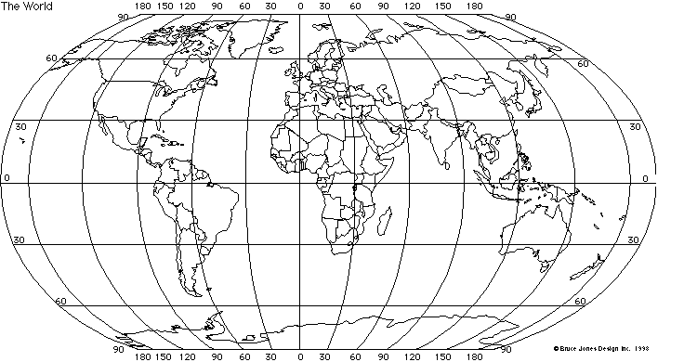

Analyze Science questions.
Science Questions:
- How does latitude affect the amount of sunlight the Earth receives?
- Why is it hotter at the equatorial region than the polar regions of the Earth?
- Considering the North Pole, the Equator, and the South Pole, where would you expect high or low pressure air pressure or global air pressure variations? Why?
- How does this relate to winds? How does this relate to global wind distribution?
- How does this relate to ocean currents?
- Possible extensions: Why do we have seasons or does this help to explain the variations of seasons in the two hemispheres?

