Vernier Labquest/Replacement Investigation

Grade: 6 Kit: FOSS Mixtures and Solutions Investigation # 1

Author(s):
Pamela Allen Tamela Anderson Luz Delia Ruiz-Monteso
Guiding Question:
- How can electricity be measured in a mixture?
- Is water able to conduct electricity?
- How do we measure conductivity in water?

Summary of Activity:
Compare a home made conductivity tool with a manufactured conductivity tool

Measure the Conductivity of the following mixtures using a homemade tool, then measure the accurate reading with the LabQuest & Conductivity Probe
- Gravel + Water
This extension lab could also be done with just earth & water
- Diatomaceous Earth + Water
- Kosher Salt + Water

Science Standards:
    - Capturing information with tools.
    - Recognize & Explain that hypotheses are valuable, even if they turn out not to be true, if they
lead to fruitful investigations.
6.2.8 Analyze & interpret a given set of findings (There may be more than one way to do so)

Math Standards
6.6.1 Organize and display single-variable data in appropriate graph

Equipment Used:
Per Group: Student Made Probe Consumable: Gravel
Vernier Labquest and Conductivity probe Baking Soda
3 Plastic cups Citric Acid Measuring Spoons Coffee Filters
Stirring Sticks
Measuring Beaker
Water & Container to hold water
Wire Screen

Students create their own Conductivity Probe (Not a part of the FOSS Investigation Kit)
Directions can be found at http://scifun.chem.wisc.edu/homeexpts/CondTester/SolutionConductivity.htm

Materials Needed: (These materials are not available with the FOSS Investigation Kit)
● a 12-volt AC adapter
This converts the 110-volt electricity from a wall socket to safer 12-volts. It must be 12 volts AC, not DC, because DC will not work for this. You may have a suitable adapter around the house from an old device you're no longer using, or you may get one from an electronics store (e.g. Radio Shack, catalog number 273-1631).
● an audio cable with a 1/4-inch or 1/8-inch monaural plug on one end
The plug will become the probe for testing conductivity. You may have an unused cable around the house. What is on the other end does not matter because it will be removed. You may also get a suitable plug-and-cable assembly from an electronics supply store (e.g., Radio Shack, catalog number 42-2381).
● a 12-volt flashlight bulb and socket
The bulb will provide a visible indication of how well a material conducts electricity. You can get these from an electronics store (e.g., Radio Shack, catalog numbers 272-1143 for the bulb and 272-357 for the socket).
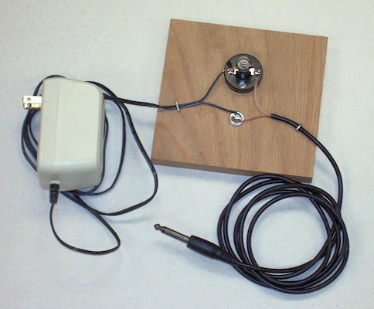
● a block of wood about 4 by 4 by 1 inch
The electrical connections will be made on this block, and the lamp will be mounted on it, too.
● two 1-inch wood screws
These hold the lamp socket to the block of wood.
● one 3/4-inch round-headed screw and washer
These will be used to make an electrical connection.
● wire cutter and wire stripper
These are used to prepare the electrical connections.
● a screw driver

Alternative to the above probe: (These materials were borrowed from ND’s Science Lab)
Use 4 D batteries (6 volts altogether) and connect them with alligator clips.
Then connect the batteries to the bulb and socket plate.
You should have 2 negative clips and 2 positive clips, put one of each on the plate, then place the other set in your water mixture.

Description of Procedures, Notes (Teacher Manual)
- Groups create their own conductivity tester.
- Students test their conductivity tester to see if electricity is present
Students will know that electricity is present if their light bulb turns on. The brightness of the bulb is an indicator of how much electricity is being conducted.
- Then they use the LabQuest and conductivity probe to accurately measure the conductivity in the mixture.
- Set up experiments as directed under Investigation 1 Separating Mixture on pages 8-15.
- Provide students with Separating Mixtures wkst (No. 2-Student Sheet)
- Provide students with Thinking About Mixtures (No. 3-Student Sheet)
- Extension Activity
  - Students put together their data in a graph
  - Students compare their data with other groups

Scientific Questions:
How can building my own conductivity tester show that electricity is present in a given mixture?
How can we measure the brightness of our own conductivity tester?
Does water by itself have conductivity?
How does battery voltage affect the lightbulb?

