NAME:____________________________________________DATE:_________ HOUR:____

MITOSIS INTERNET LAB

Internet Activity #1

www.cellsalive.com

On the left hand of the screen is a navigation bar, click on the link to “MITOSIS”. Read the text on this page and view the animation. You can slow down the video by clicking step by step through the phases.

Which stage does the following occur:

1. Chromatin condenses into chromosomes __________________________________

2. Chromosomes align in the center of the cell __________________________________

3. Longest part of the cell cycle __________________________________

4. Nuclear envelope breaks down __________________________________

5. Cell is cleaved into two new daughter cells __________________________________

6. Daughter chromosomes arrive at the poles __________________________________

Watch the video carefully. The colored chromosomes represent chromatids. There are two of each color because one is an exact duplicate of the other.

7. How many chromosomes are visible at the beginning of mitosis? ______________

8. How many chromosomes are in each daughter cell at the end of mitosis? _____________

9. What are the little green “T” shaped objects in the cell? _________________________

10. What happens to the centrioles during mitosis? _______________________________

11. Identify the stages of these cells.

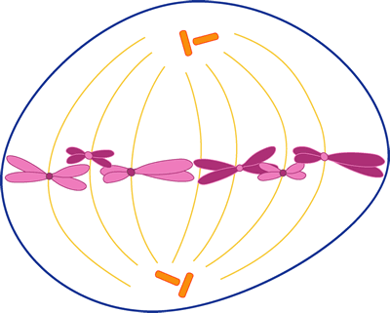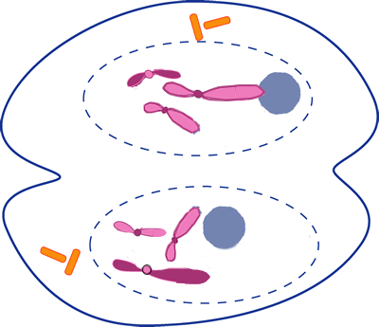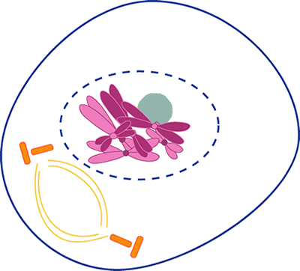

A. _____________________ B._______________________ C. _____________________
Internet Activity #2

www.sci.sdsu.edu/multimedia/mitosis/

12. What is a eukaryote?__________________________________________________________

13. What is a non-reproductive cell? _______________________________________________

Click on “What is Mitosis” after the page has loaded to view the animation and complete the following table.

PHASE | What happens during this phase?
Interphase | 14.
Prophase | 15.
Prometaphase | 16.
Metaphase | 17.
Anaphase | 18.
Telophase | 19.

Internet Activity #3

www.johnkyrk.com/mitosis.html

View the animation and sketch the animation in the following phase.

Prophase | Metaphase | Telophase
Internet Activity #4

www.biology.arizona.edu/cell_bio/activities/cell_cycle/cell_cycle.html

Read the information on the first few introduction web pages. Answer the following questions.

20. Explain why the roots of plants are a ideal for studying the cell cycle.

21. List the five major phases of the life cycle of a cell.

Click on the NEXT button each time you complete the readings. You will have 36 cells to classify. When you’re finished, record your data in the chart below. Round to whole numbers.

 | Interphase | Prophase | Metaphase | Anaphase | Telophase | Total
Number of Cells
Percent of Cells
** Percent of cells = (Number of cells in the phase/ Number of total cells) X 100

Instructional Notes: Mitosis Computer Activity

Pre-activity Discussion
This is a set of computer activities accumulated to help reinforce the students’ understanding of mitosis.

Activity Performance Notes
Four websites will utilized, questions to answer while the students work are also included.
www.cellsalive.com
www.sci.sdsu.edu/multimedia/mitosis/
www.johnkyrk.com/mitosis.html
www.biology.arizona.edu/cell_bio/activities/cell_cycle/cell_cycle.html

Post-activity Discussion
Discuss what the students have learned while working through the four websites.

